Test Case: runTestMultipleTimes
Step 1 - Enter username and password and click to button Enter : Credentials Entered
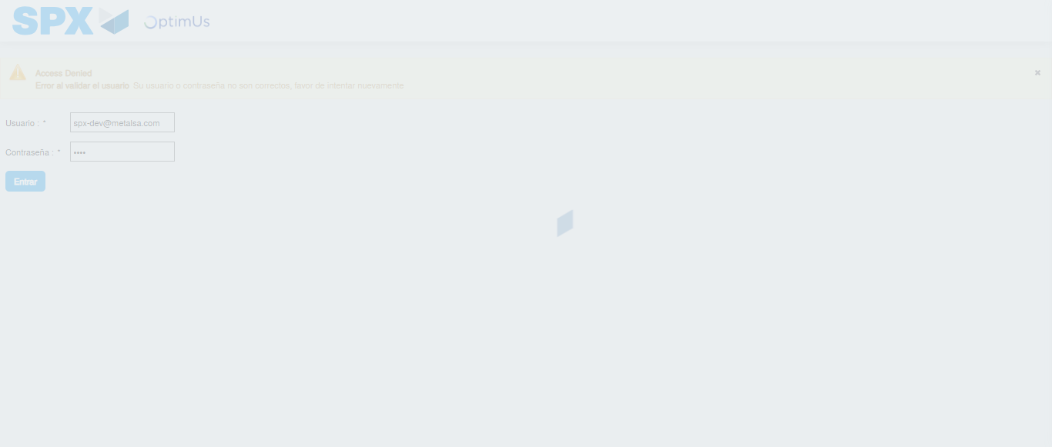Image file-name: QC_Testing-runTestMultipleTimes-nov. 20 2025, 02 19 49 p. m.

Step 2 - Select to UEN and Access to Administrador Roles Menu: UEN Correctly selected and Correct access
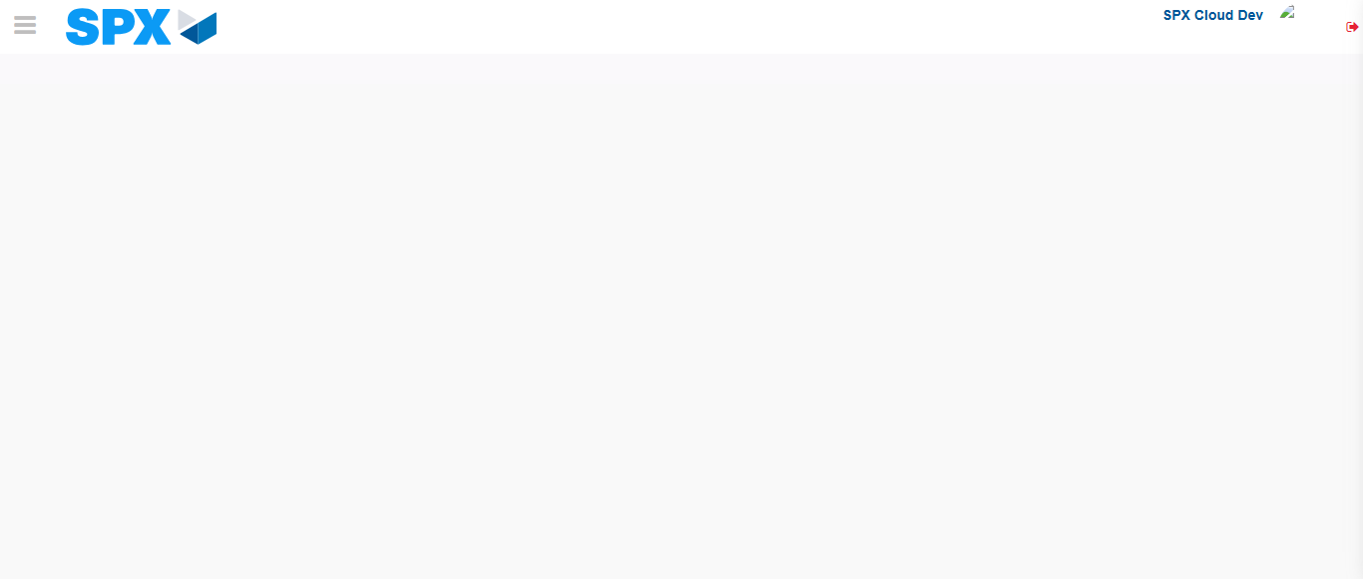Image file-name: QC_Testing-runTestMultipleTimes-nov. 20 2025, 02 19 52 p. m.

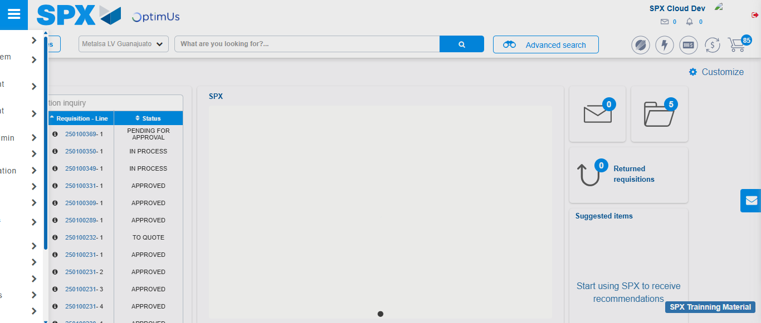Image file-name: QC_Testing-runTestMultipleTimes-nov. 20 2025, 02 19 53 p. m.

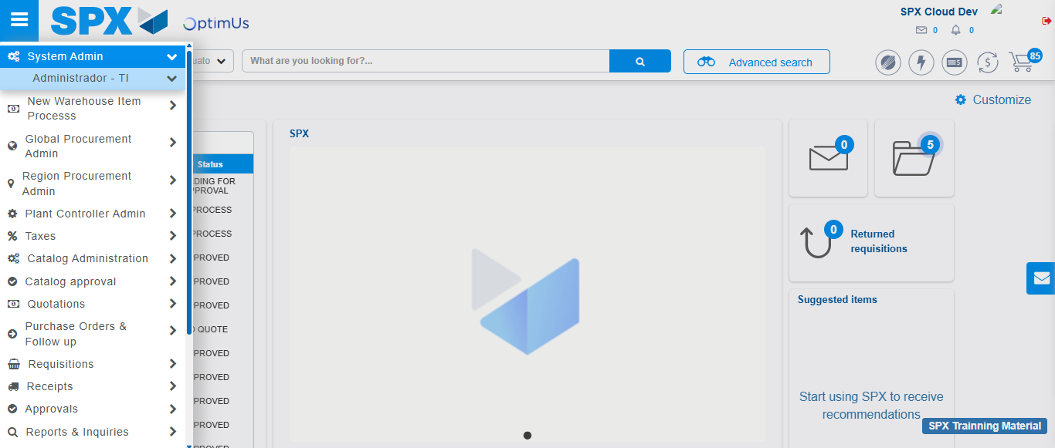Image file-name: QC_Testing-runTestMultipleTimes-nov. 20 2025, 02 19 54 p. m.

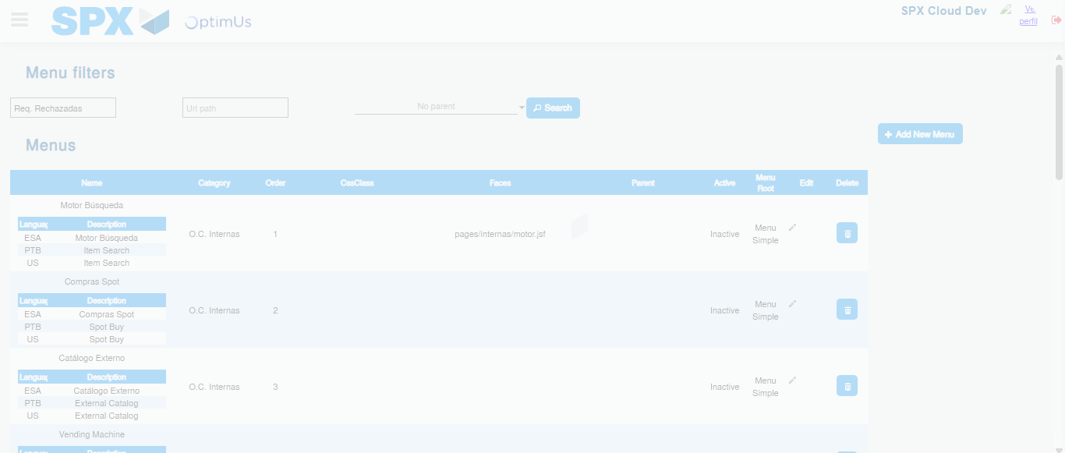Image file-name: QC_Testing-runTestMultipleTimes-nov. 20 2025, 02 19 56 p. m.

Step 3 - Perform a search with the Menu Name filter: Successful search
Image file-name: QC_Testing-runTestMultipleTimes-nov. 20 2025, 02 19 56 p. m.

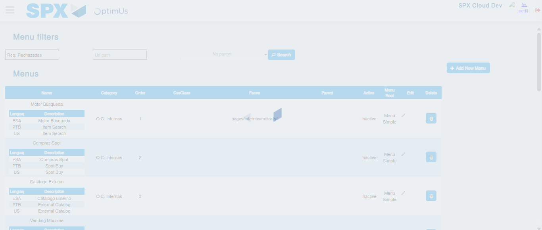Image file-name: QC_Testing-runTestMultipleTimes-nov. 20 2025, 02 19 57 p. m.

